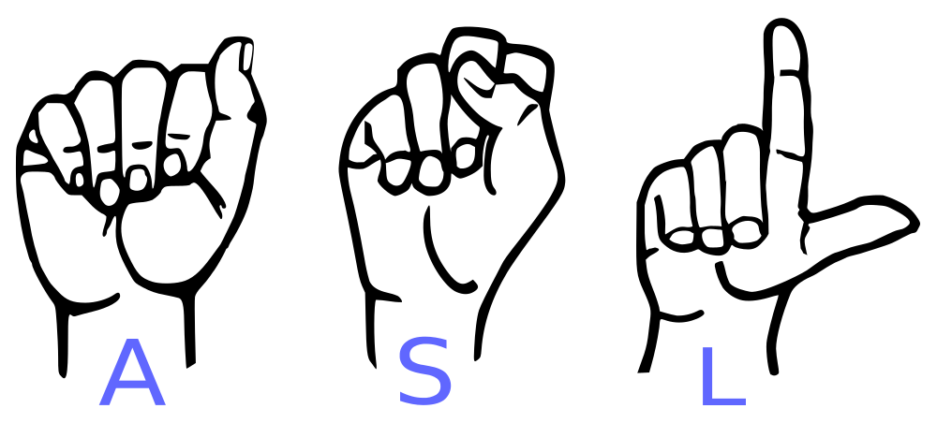

1A COURSE SYLLABUS

**____________________________________________________________________**



**COURSE DESCRIPTION**

This class will focus on basic expressive/presentational and receptive/interpretation skills in American Sign Language and an introduction to American Deaf Culture. Weekly interactive activities and Google Classroom practice, presentational via video, self and peer evaluations allow you to rehearse, what you’ve learned in class. Upon completion, students will be able to comprehend and respond with near grammatical accuracy to expressive American Sign Language and demonstrate basic cultural awareness.

**Unit 1**- Welcome

**Unit 2**- Getting Started

**Unit 3** Getting to Know You

**OBJECTIVE**Students will be able to engage in meaningful, intercultural communication through the signed language with the vocabulary taught, including body language, facial expressions. Students will be able to interpret one-way signs and body language (receptive), participate in two-way interpersonal (such as dialogues), and one-way presentational (expressive) communication. Students will gain an understanding of the perspectives of other cultures and compare the language and cultures learned with their own. Students will participate in dialogues, presentations and class activities in ASL which highlight facial expression, body language, hand shapes, eye gaze, mouth morphemes and head movement as it is communicated in the target language, ASL.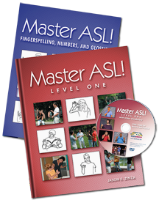

**MATERIALS**

You will need the following:

Notebook

pen/pencil

3 binder or notebook

A creative mind

Hands ready to work

We will be using the textbook/workbook *Master ASL! Level One* by Jason E. Zinza and other supplemental materials.

**CLASS EXPECTATIONS**

**Attendance:**

This class follows the Anoka High School attendance policy. If you are absent, it is **your responsibility** to check with me or a friend in class to see what was missed. Be on time! Attendance is crucial. ASL is best learned in class.

**ASL Zone:**

It’s crucial to maintain a signing environment, therefore no talking is allowed in the classroom unless otherwise instructed. ASL is a visual/gestural language, one of which you are not accustomed to. Develop the habit early to sign everything and include the Deaf person, meaning your teacher. The more you sign, the easier it becomes. This is an immersion class and you will be using the target language often. Using daily ASL will help you develop the skills you need for both receptive and expressive ASL. You will need to use not only your hands to communicate, but your face which includes your eyes, eyebrows, lips and sometimes your nose! Also you will learn how to use your body, and the signing space. In order to progress, it is important that you become comfortable using facial expressions, body language and attending (listening) with your eyes. To encourage and foster the development of these skills, using your voice in the classroom will be avoided as much as possible. Use other means to communicate with me. **Consistent talking in class and not using the target language will consist in a call/email home and/or referral to your assistant principal.**

**Electronics:**

All electronics should be turned off during class time. In addition, they should be out of sight, meaning they should be put in your pocket or backpack not left on your desk unless directed by your teacher. Broken eye contact can easily be spotted by your teacher. If you are seen using an electronic device consistently, you will be asked to place it on my desk until the end of class. Repeated behaviors will result in a call/email home, and/or referral.

**Late work:**

Submitting late work particularly formative work by the assigned due date is critical to the standards based grading and allows me to provide timely feedback. Late work is accepted in a timely manner, it must be discussed with me beforehand.

**Retakes:**

In accordance with the Anoka High School student contract, you are allowed to retake a quiz. All practice activities prior to the quizzes are not graded thus are optional, however if you want to retake a quiz and have not done the practice activities assigned in Google Classroom, you must do the practice videos first prior to re-taking the quiz (receptive). As for expressive formative grades, you may re-do if the learning target is not met and/or you are not satisfied with your grade, however you must discuss this with me beforehand. This also applies to dialogues (Interpersonal). Summative exams (unit exams) may not be retaken. There is a time limit for retakes, do not wait 10 weeks to re-take any of your formatives! Be sure to check your grades weekly. Retakes can be arranged during advisement or after school.



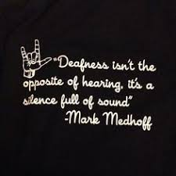

**Syllabus Signature Sheet**

As the student, I have read the course syllabus and am aware of the course objectives and expectations, grading policy, and cheating policy. I am responsible for adhering to the expectations and I am aware of the rewards/consequences associated with my decisions.

_______________________________________________ ____________

Printed Name of Student Date

_______________________________________________

Signature of Student

As the parent/guardian of the above named student, I have read the course syllabus and am aware of the expectations of my student.

________________________________________________ _____________

Signature of Parent/Guardian Date

_____________________________________________________________________________

Email address (for future contact regarding your child)

***Return to Mrs. Kohl by: ______________________***